Description on how to download historical daily data from Sharenet:

Set-up:

- Copy the following line and append to your existing “mywebserver.txt”, or simply substitute it the attached “mywebserver.txt”.

Stock_Sharenet_D,http://www.sharenet.co.za/jse/SSSS,D1,Sharenet_D1.fmt

- Copy the “Sharenet_D1.fmt” file to the “fmt” subfolder.
- Run HSQuote Plus and set up the screen as shown:

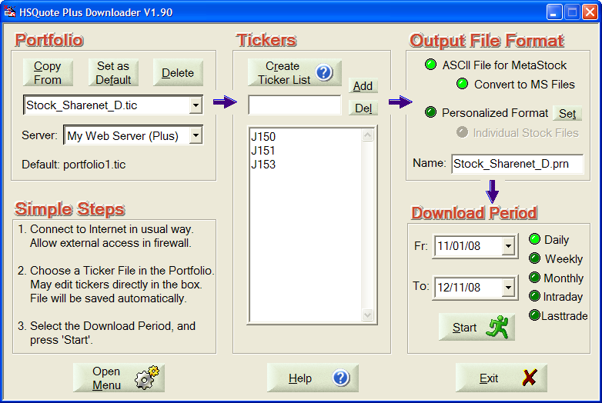

Historical Daily Data Download:

For the first time, you may set the Fr date as far back as two week from today. Later, the last successful download date is automatically stored, and the Fr Date will start from this successfully download date.

